**Using build.bat to compile Java source files**

**Steps:**  
1) Create a directory containing the build.bat script.   
  
2) Create a “src” sub-directory and copy-in the Java source files to compile.  
Note: The soure files need to be manually extracted from the relevant CW git repository.   
  
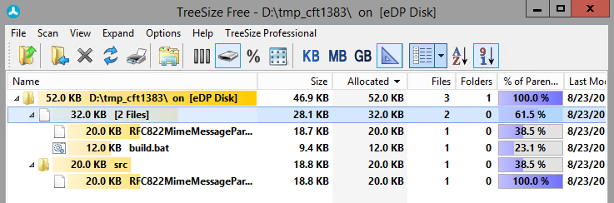  
(I’ve also kept a copy of the original java file directly under “D:\tmp_cft1383”, so I can compare it with my edited version in “D:\tmp_cft1383\src\”).  
  
3) Make any required edits to the Java source files.  
  
4) Compile the java source files using “build”.  
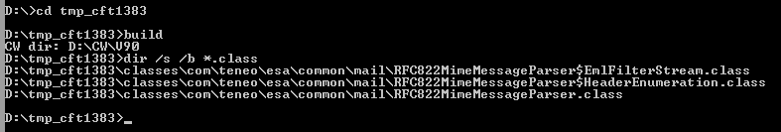  
  
Note: There will now be class files generated. The build.bat script can use these file names in a minute to determine if these files will be replacing existing files in the product. If they will be replacing existing files, the “build -b” option can back-up the original class files for you, into the local “orig” directory.  
  
5) Backup the existing class file(s) using “build -b”.  
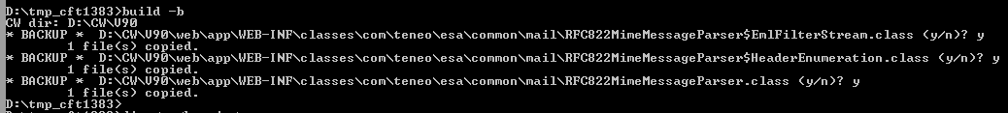  
  
Copies of the original class files are now backed-up here:  
  
6) Install our newly-builtclass file(s) using “build -i”.  
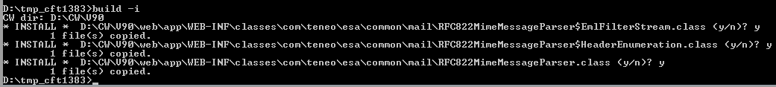

7) Restart CW.

*JeremyC 23-08-2018***END**